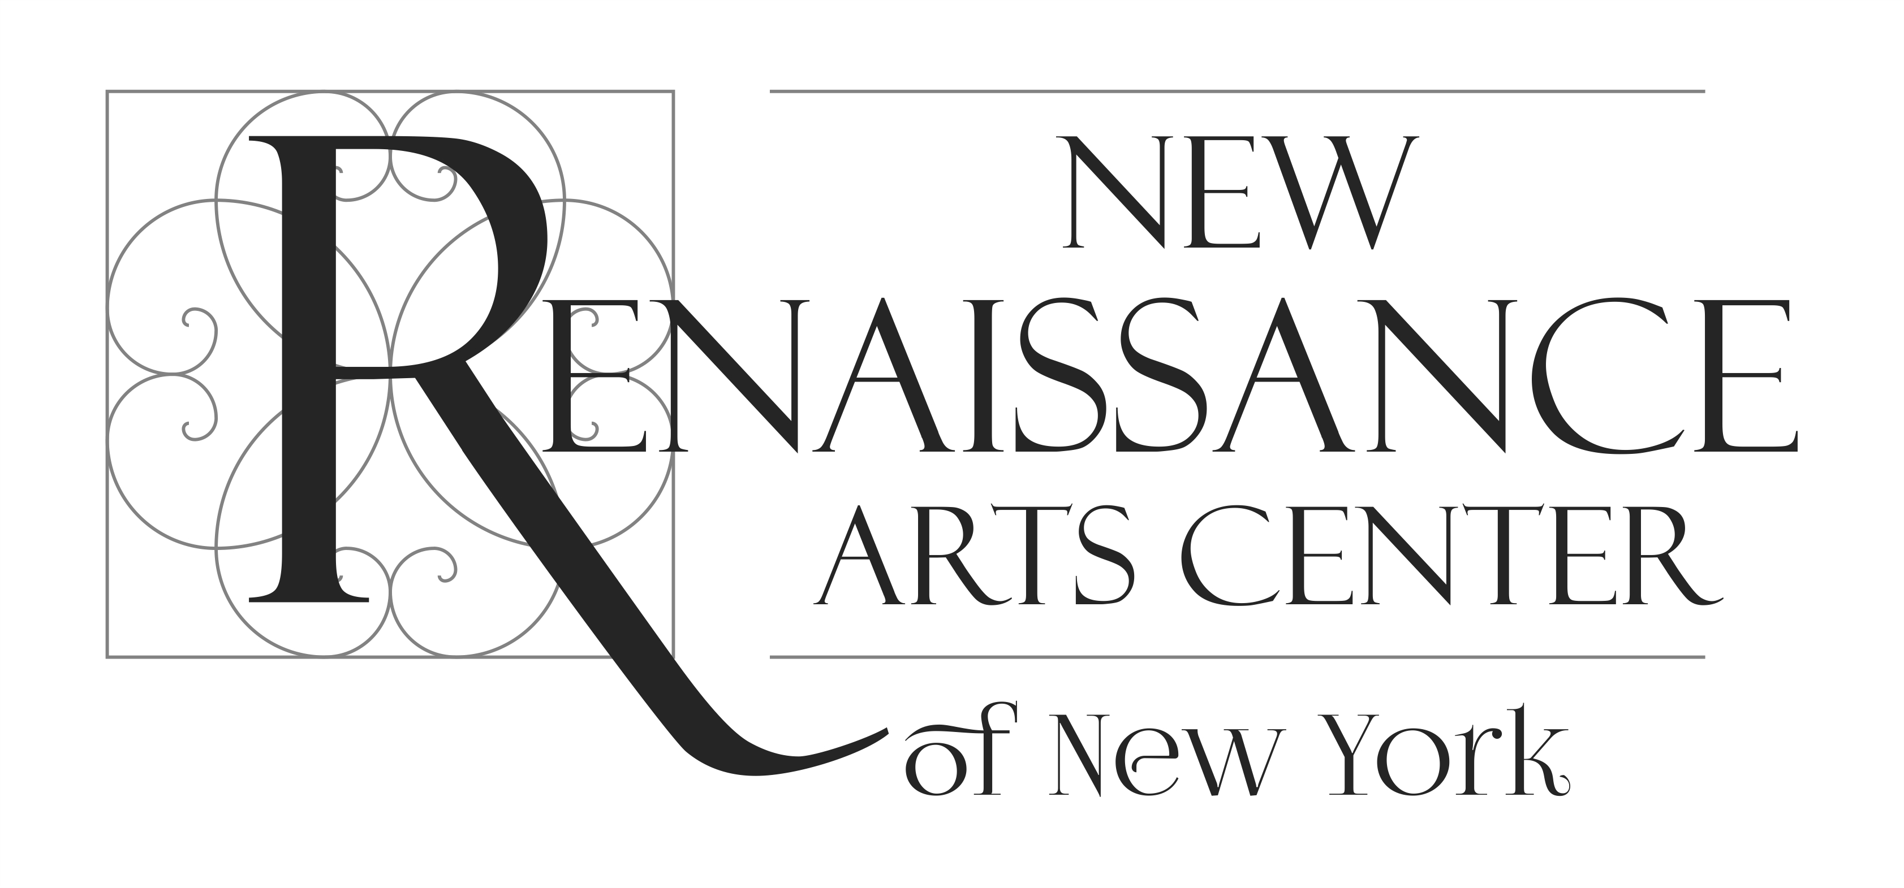
SUMMER STUDIO
ART PROGRAM 2020

REGISTRATION FORM

Student’s Name and Last Name click here to write.
Age click here to write Date of Birth click here to write
Gender Male or Female.
Parent/Guardian’s name (in case of minor age students) click here to write.
Address click here to write
City or Town click here to write. State click here to write.
Zip Code click here to write.
Phone number click here to write. Cell Phone click here to write
Email click here to write.
Alternative contact: Name click here to write. Phone click here to write.
Previous art studies click here to write
Occupation click here to write

REGISTERING TO THE CLASS: (mark with an X the class and tuition of your choice)

SUMMER ART CLASSES From June 22nd to August 1st
HALF DAY ART CLASS ☐ 6 Week Program
Monday to Saturday from 10:00 am to 1:30 pm
Tuition Payment: Per class $ 50 ☐ Weekly $ 250 ☐ (Saturday included)
Joining the class starting on date:MM/DD/YY
EVENING DAY ART CLASS ☐ 6 Week Program
Monday, Wednesday and Friday from 4:00 to 7:00 pm
Tuition Payment: Per class $ 50 ☐ Weekly $ 150 ☐
Joining the class starting on date:MM/DD/YY
SATURDAY ART CLASS ☐ OR RESTORATION WORKSHOP ☐ Saturdays from 10:00 am to 1:30 pm.
Tuition Payment: Per class $ 50 ☐ Full Program (6 sessions) $ 300 ☐
Joining the class starting on date MM/DD/YY.

Office use only
Date: _____/_______/_______
Payment amount: _________________________
Payment method: _________________________
Notes:_____________________________________________________________________________

Name and last name.

Applicant’s Signature
or signature of Parent /Guardian’s (in case of minor age students)

